**United States Department of Agriculture**

Food and Nutrition Service

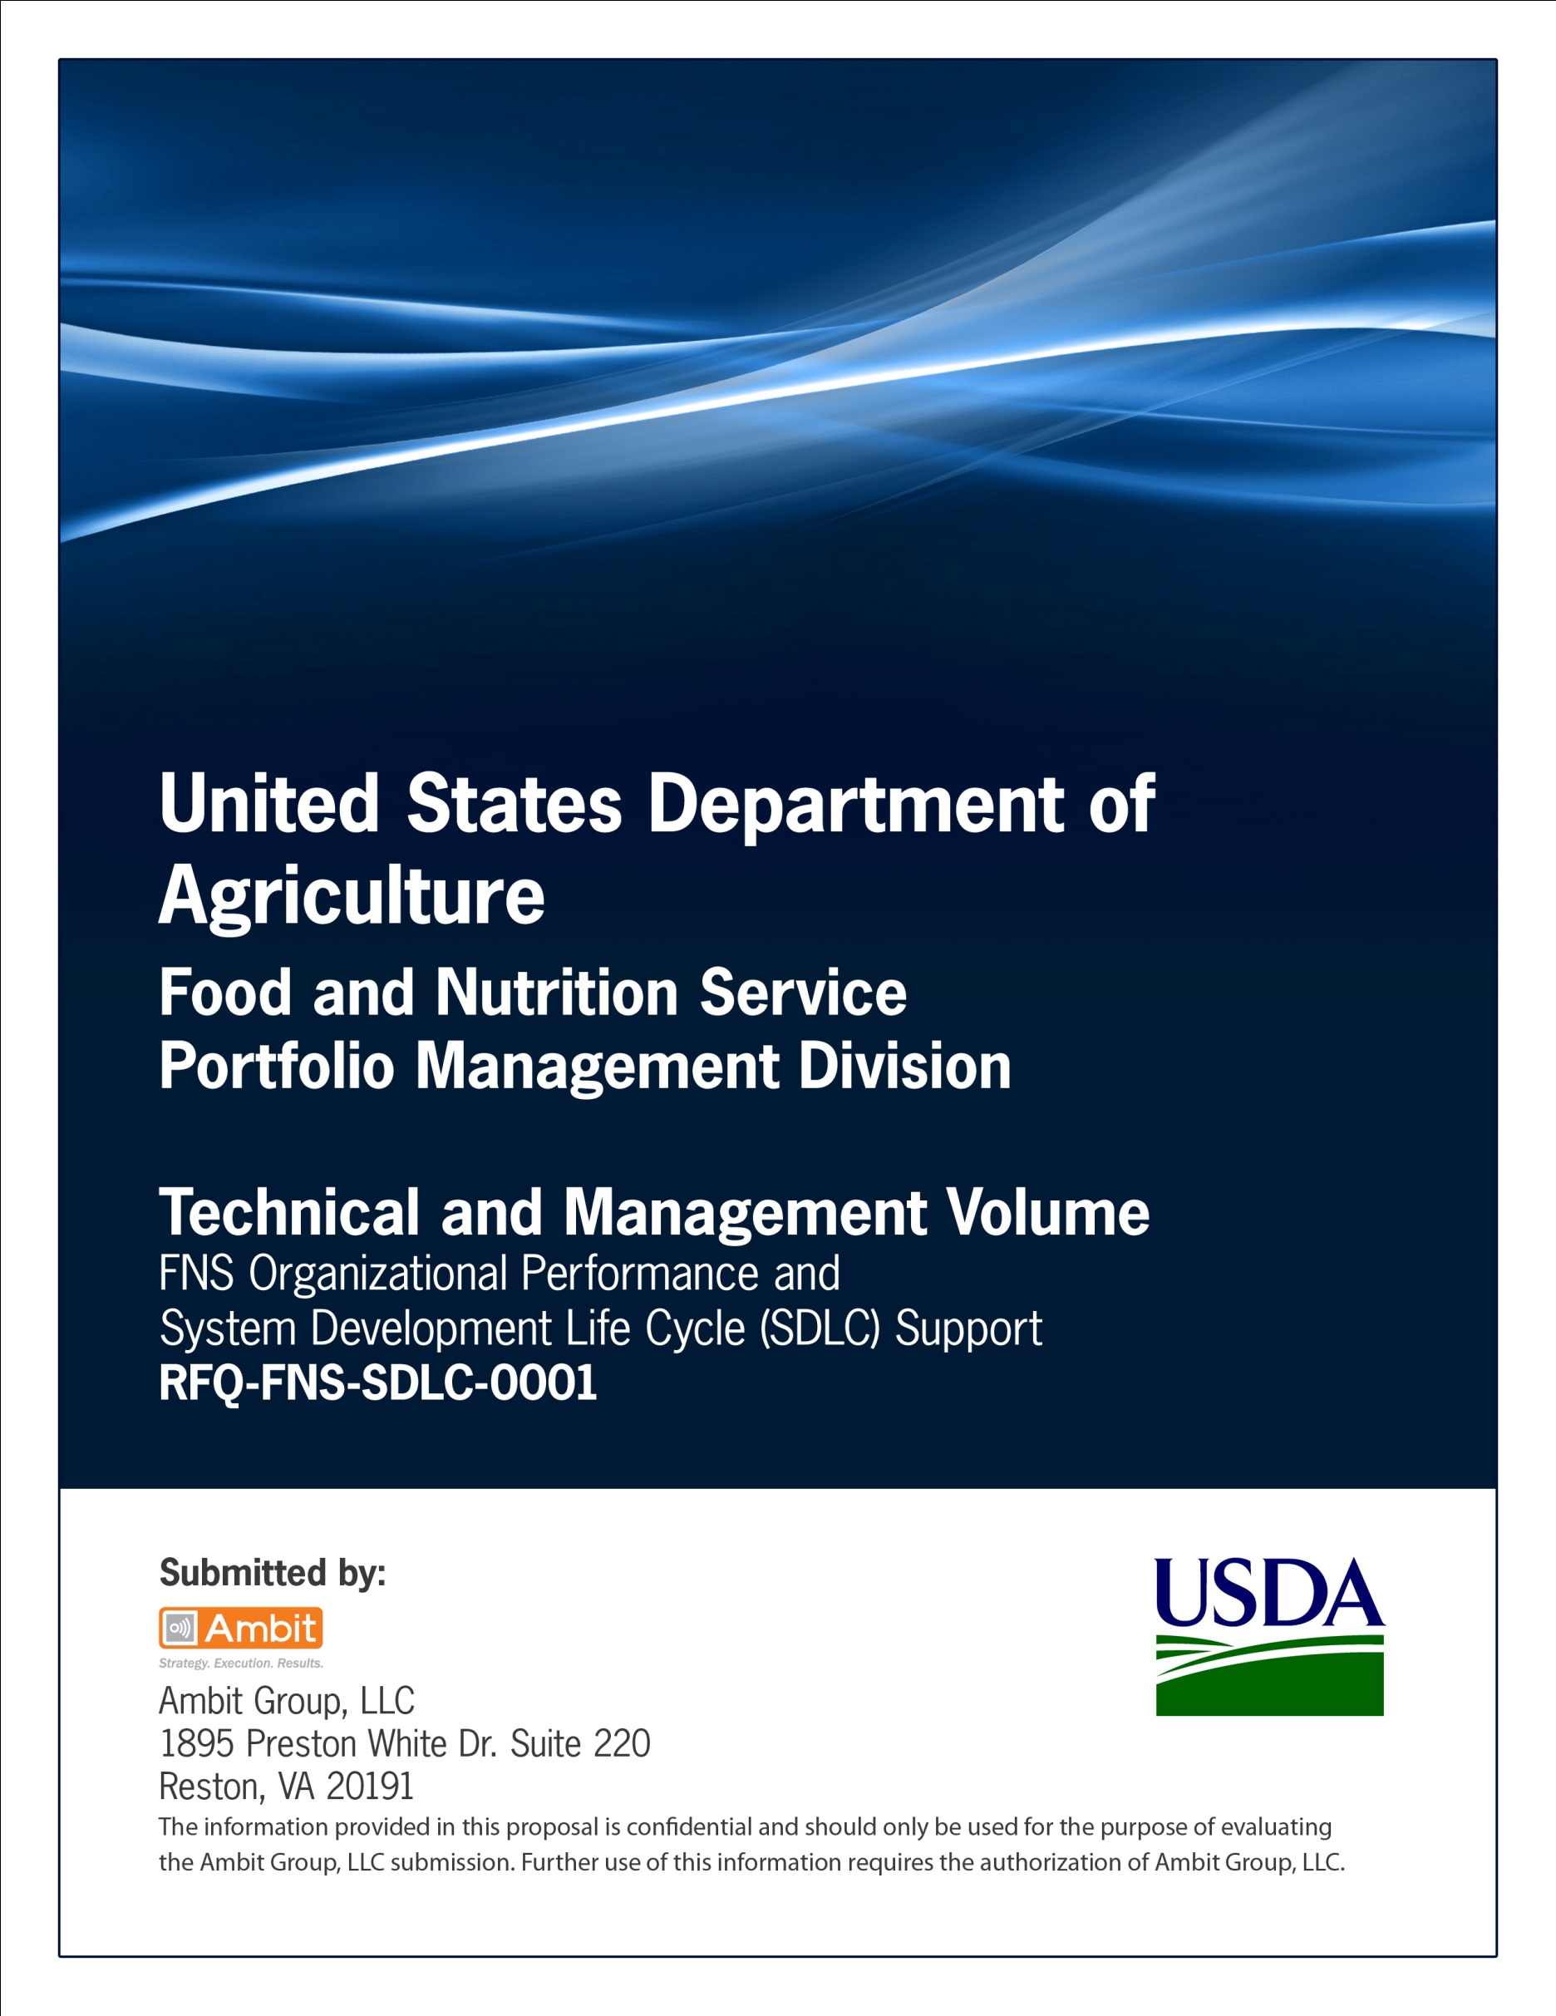

**FNS Office of Information Technology**

**Portfolio Management Division (PMD)**

**FNS Configuration Management Plan Template**

**for**

**[Project or System Name]**

**Version 1.1**

September 09, 2013

**Revision History**

|  |  |  |  |
| --- | --- | --- | --- |
| **Version** | **Date** | **Author** | **Change Description** |
| 1.0 | 03-21-2013 | IT Governance Branch (ITGB) | Created the document. |
| 1.1 | 09-09-2013 | IT Governance Branch (ITGB) | Re-formatted the document. |
| 1.2 |  |  |  |
| 1.3 |  |  |  |

**Contact Information**

|  |  |
| --- | --- |
| **Area of Concern** | **Contact Person** |
| IT Governance Lead | Kevin Russ |
| SDLC Coordinator | Syed Jaffery |
| ITIRB Coordinator | Sunny Dilawari |
| Portfolio Management Division Director, Chief Portfolio Officer | Jacqueline Butler |
| Program Management Branch Chief | Allison Willcox |

Contents

Glossary 4

1. Overview 5

1.1. Purpose 5

1.2. Scope 5

1.3. System Overview and Background Information 5

1.4. Intended Audience 5

1.5. Responsibilities 5

2. CM Resources 5

2.1. Software Tools, Techniques, and Methodologies 5

2.2. Personnel 5

2.3. Training 5

3. CM Activities 5

3.1. Configuration Identification 5

3.2. Naming Conventions 6

3.3. Version Numbering 6

3.4. Establish Baselines 6

3.5. Releases 6

3.6. Handling of Non-Conforming Products 6

3.7. Storage and Retrieval of CIs 6

4. Change Control 6

4.1. Requesting Change 6

4.2. Evaluating Changes 6

4.3. Approving/Disapproving Changes 6

4.4. Implementation of Changes 6

5. Configuration Status Accounting 6

6. Configuration Auditing and Reviews 6

Appendix A: References 7

Approvals/Signatures 8

# Glossary

| **Acronym** | **Description** |
| --- | --- |
|  |  |
|  |  |
|  |  |
|  |  |
|  |  |
|  |  |
|  |  |
|  |  |

# Overview

## Purpose

Describe the purpose.

## Scope

Describe the scope.

## System Overview and Background Information

Describe the system overview and background information.

## Intended Audience

Describe the intended audience.

## Responsibilities

Describe the responsibilities.

# CM Resources

## Software Tools, Techniques, and Methodologies

Describe the software tools, techniques and methodologies.

**Directory Structure**

Describe the directory structure.

**Access Controls**

Describe the Access Controls.

## Personnel

Describe the personnel.

## Training

Describe the training provided.

# CM Activities

## Configuration Identification

Describe the configuration identification.

## Naming Conventions

Describe the naming conventions.

## Version Numbering

Describe the version numbering.

## Establish Baselines

Describe the established baselines for configuration management.

## Releases

Describe the releases.

## Handling of Non-Conforming Products

Describe the handling of non-conforming products.

## Storage and Retrieval of CIs

Describe the storage and retrieval of CIs.

# Change Control

## Requesting Change

Describe the process for requesting change.

## Evaluating Changes

Describe the process for evaluating changes.

## Approving/Disapproving Changes

Describe the process for approving and disapproving changes.

## Implementation of Changes

Describe the process for implementation of changes.

# Configuration Status Accounting

Configuration status accounting helps in identifying the information regarding the status of the Configuration Items (CIs) and the changes affecting them. Describe the Configuration Status Accounting.

# Configuration Auditing and Reviews

Describe the Configuration Auditing and Reviews.

# Appendix A: References

Insert the name, version number, description, and physical location of any documents referenced in this document. Add rows to the table as necessary.

The following table summarizes the documents referenced in this document.

|  |  |  |
| --- | --- | --- |
| **Document Name** | **Description** | **Location** |
| Document Name and Version Number | Document description | URL or Network path where document is located |
|  |  |  |
|  |  |  |

# Approvals/Signatures

The undersigned acknowledge that they have reviewed the [name of document] document and agree with the information presented within this document. Changes to this document will be coordinated with, and approved by, the undersigned, or their designated representatives.

|  |  |  |  |
| --- | --- | --- | --- |
| Signature: |  | Date: |  |
| Print Name: |  |  |  |
| Title: |  |  |  |
| Role: | [Project or System Name] Project Manager |  |  |
|  |  |  |  |
| Signature: |  | Date: |  |
| Print Name: |  |  |  |
| Title: |  |  |  |
| Role: | [Project or System Name] Business Owner |  |  |
|  |  |  |  |
| Signature: |  | Date: |  |
| Print Name: |  |  |  |
| Title: |  |  |  |
| Role: | Organization’s Approving Authority |  |  |